Open Space and Recreation Needs Analysis and Strategy
Report Authors Lisa Proctor, Development Planner
Daniel Aldridge, Executive Manager Community Spaces
File No. / ECM Index
Date of Meeting 9 March 2022
Authorising Director Paul De Szell, Director Liveable Communities

SUMMARY OF REPORT

This report seeks a resolution of Council to undertake the community engagement for the MidCoast Open Space and Recreation Strategy.

SUMMARY OF RECOMMENDATION

- That community engagement be undertaken to inform the development of the draft MidCoast Open Space and Recreation Strategy, beginning with the exhibition of the draft MidCoast Open Space and Recreation Needs Analysis.

FINANCIAL/RESOURCE IMPLICATIONS

Nil

LEGAL IMPLICATIONS

Nil

ATTACHMENTS

A: Draft MidCoast Open Space and Recreation Needs Analysis
B: List of Councils’ public open spaces and assets managed for recreation purposes
C: Spatial distribution mapping of Councils’ public open spaces and assets managed for recreation purposes
D: Community Engagement Plan

BACKGROUND
Recognition of the value of public open space is significantly increasing in government policy. In 2019 the NSW Ministry for Planning and Public Spaces was created, with commitments from the NSW Government to support Council-led open space strategies. Those commitments complement Council’s own policies to improve public open space for the benefits of the MidCoast community.
The recreation and open space strategies that were current at the time of the MidCoast Council proclamation were:

• Great Lakes Council Recreation and Open Space Strategy, July 2006
• Draft Gloucester Recreation Management Plan, undated
• Greater Taree Open Space and Recreation Strategy, 2011

A single Open Space and Recreation Strategy is required for MidCoast to implement best practice recreation and open space planning, current demographic and asset data and community input. The Strategy will help to guide Council’s prioritisation and decision making on open space and recreation facilities across MidCoast for the period 2023 to 2036.

A draft Open Space and Recreation Needs Analysis has been prepared to review the distribution of current recreational facilities and identify a need for new and updated facilities, in accordance with Council’s Delivery Program and Operational Plan. That Needs Analysis is included at Attachment A of this report. Attachment B of this report is a spreadsheet of Council’s public open spaces managed specifically for recreation. That spreadsheet details all of the assets available in each space. Attachment C of this report is spatial distribution mapping of all of Council’s public open spaces managed specifically for recreation. Attachment D of this report is the Plan for how we intend to engage and consult with the community for this project.

DISCUSSION

Informed by changing population needs and community expectations identified throughout the Needs Analysis, the Strategy will be a blueprint for open space and recreation planning up to 2036. The purpose of the Strategy is to guide how Council will plan, implement and manage current and future open spaces, sport, recreation, aquatics and associated community infrastructure.

The MidCoast Open Space and Recreation Strategy is being undertaken in 10 steps. The preparation of the Needs Analysis is step 1 of the process in moving towards a MidCoast Open Space and Recreation Strategy. The Needs Analysis includes a desktop review of the attributes of Council’s owned and managed open space, including sport and recreation facilities, as well as a review of policy and research, demographics and statistics and best practice open space and recreation planning.

The diagram below illustrates the process for the preparation of the MidCoast Open Space and Recreation Strategy.
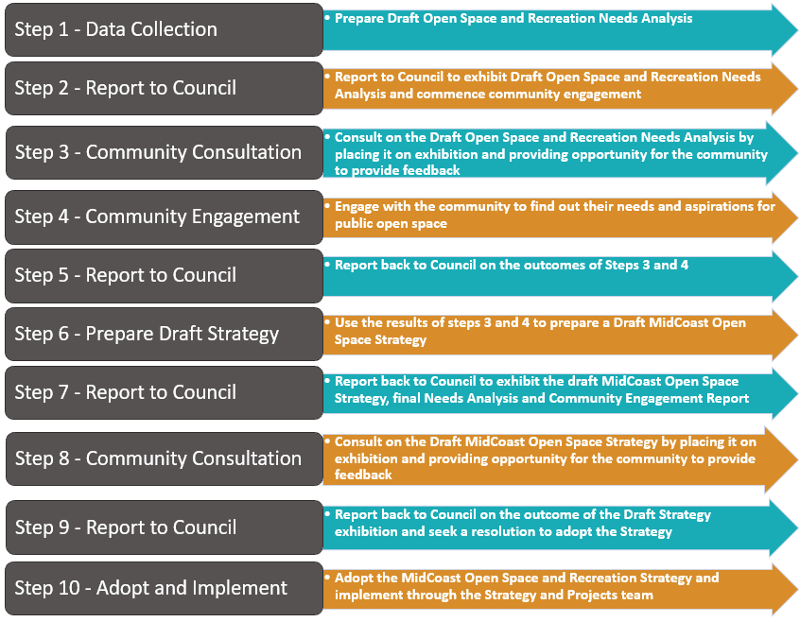

CONSULTATION
An engagement plan has been developed to guide the way we work with our community on the development of the Open Space Strategy. The Community Engagement Plan at Attachment D of this report details the proposed approach to consultation and engagement.

COMMUNITY IMPACTS

Public open spaces make local neighbourhoods more welcoming and accessible, support physical and mental health and well-being, environmental resilience and social cohesion. There is also a recognition of the ability of public open spaces to create thriving local economies.

Research undertaken by the NSW Government found that people in NSW were using and appreciating public space more than ever during the Covid-19 pandemic, and 12 months on, the use of public spaces remains high, even as restrictions are eased. In 2020 and 2021, approximately 45% of people were spending more time in public spaces compared to before the pandemic.

The community impacts of activating and improving Council’s public open spaces are likely to be highly positive for both current and future generations.

ALIGNMENT WITH COMMUNITY PLAN/OPERATIONAL PLAN

The MidCoast Community Strategic Plan drives the vision for MidCoast into the future and is at the centre of the community’s desire for well-planned and maintained open spaces. The theme that is weaved through the title and content of the document, “Shared Vision, Shared Responsibility”, is particularly relevant as the community in MidCoast often work with Council, in a voluntary capacity, to maintain or improve public spaces. During the engagement for the Strategic Plan the community often expressed a sense of ‘ownership’ of Council’s open spaces.

There are several areas in the MidCoast Community Strategic Plan that are relevant to public open space:

- Provide equitable access to services, programs, spaces, and facilities.
- Encourage public spaces, facilities and events that strengthen social connections.
- Ensure growth and new development complements our existing natural assets.
- Optimise land use to meet our environmental, social, economic, and developmental needs.
- Develop and promote our region as an attractive visitor destination offering products and experiences that meet the needs of our visitors and residents.

The 2018 – 2022 Delivery Program and 2021 – 2022 Operational Plan includes:

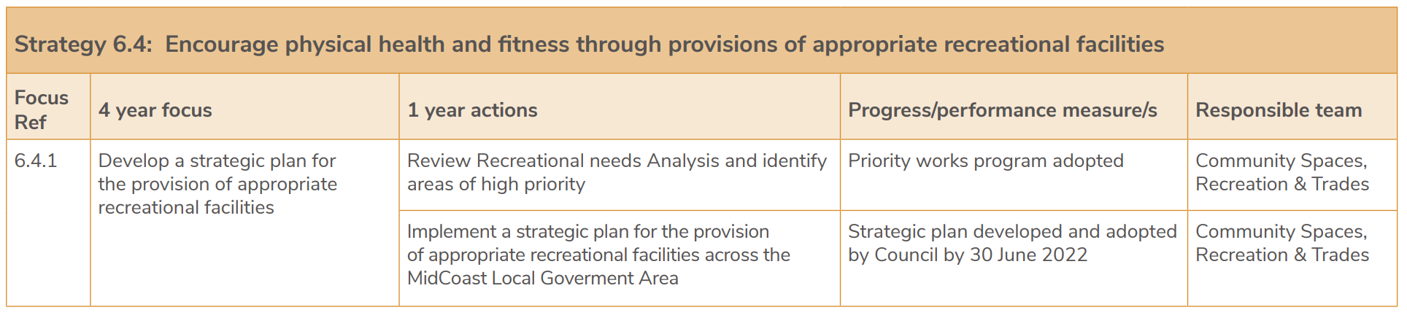

TIMEFRAME

The Open Space Strategy timeframe 2023 to 2036 aligns with MidCoast Council’s existing population forecasts, giving Council a thirteen-year plan to address its open space and recreation needs taking into consideration our present and future population and demographics. It is anticipated that periodic reviews of the Strategy will be undertaken to ensure that it remains relevant.

BUDGET IMPLICATIONS

Facilitation of the activities outlined in the attached Community Engagement Plan will cost approximately $50,000.

The total above comprises of 12 community facilitation sessions @ $3,000 each and a phone survey @ $14,000.

The cost can be accommodated within the existing Community Spaces budget.

RISK CONSIDERATION

It is unlikely that the Open Space Strategy will pose a risk for Council.

RECOMMENDATION

- That community engagement be undertaken to inform the development of the draft MidCoast Open Space and Recreation Strategy, beginning with the exhibition of the draft MidCoast Open Space and Recreation Needs Analysis.

NSW Department of Planning, Industry and Environment. November 2021. Public Spaces during Covid-19: Adapting to the new normal.

